**Experiment Name :- Yagi Uda Antenna**

*Student Name :- Mr.*

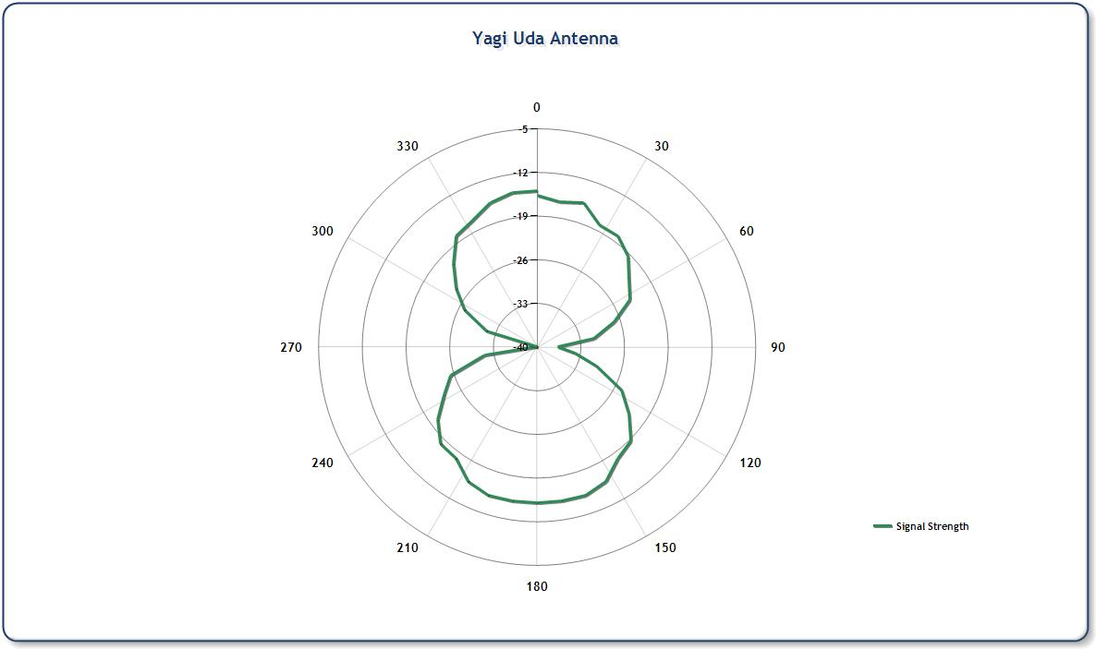

*signature of class teacher*